BookIT

Software Design Documentation

**Airline Reservation Service**

1 Introduction 1

1.1 Purpose 1

1.2 Scope 1

1.3 Overview 1

1.4 Version Change 1

2 Use Cases 2

2.1 Actors 2

2.2 List of Use Cases 2

2.3 Use Case Diagrams 2

2.4 Use Cases 2

3 Design Overview 3

3.1 System Architecture 3

3.2 System Objects 3

3.2.1 Class Diagrams 3

3.2.2 Class Diagrams Descriptions 3

3.3 Constraints and Assumptions 3

3.4 Design Pattern 3

4 User Interface and Wireframes 4

4.1 Wireframes 4

4.2 User Interfaces 4

5 Database Design 5

5.1 Entity Relationship Diagram 5

6 Dynamic Model 6

6.1 Flowchart Diagram 6

6.2 State Diagram 6

7 Non-Functional Requirements 7

7.1 Performance Requirements 7

7.2 Design Constraints 7

8 Testing 8

8.1 Test Cases 8

Figure 1 Entity Relationship Diagram 8

# Introduction

## Purpose

BookIT aim to allow a user to book a plane ticket, check the seats on each route.

## Scope

## Overview

dsd

## Version Change

dsd

# Use Cases

## Actors

Client

Admin? (optionnal)

Compagnie aérienne? (bonus)

## List of Use Cases

Client:

* Create an account
* Search all flights
* Search a flight by date
* Search a flight by price
* Check avaible seats on a flight
* Book a seat on a flight
* Manage reservations

Admin (optionnal) :

* Cancel a reservation
* Check all reservations
* Update a reservation

Compagnie aérienne (bonus) :

* Add a route
* Update fly status

## Use Case Diagrams

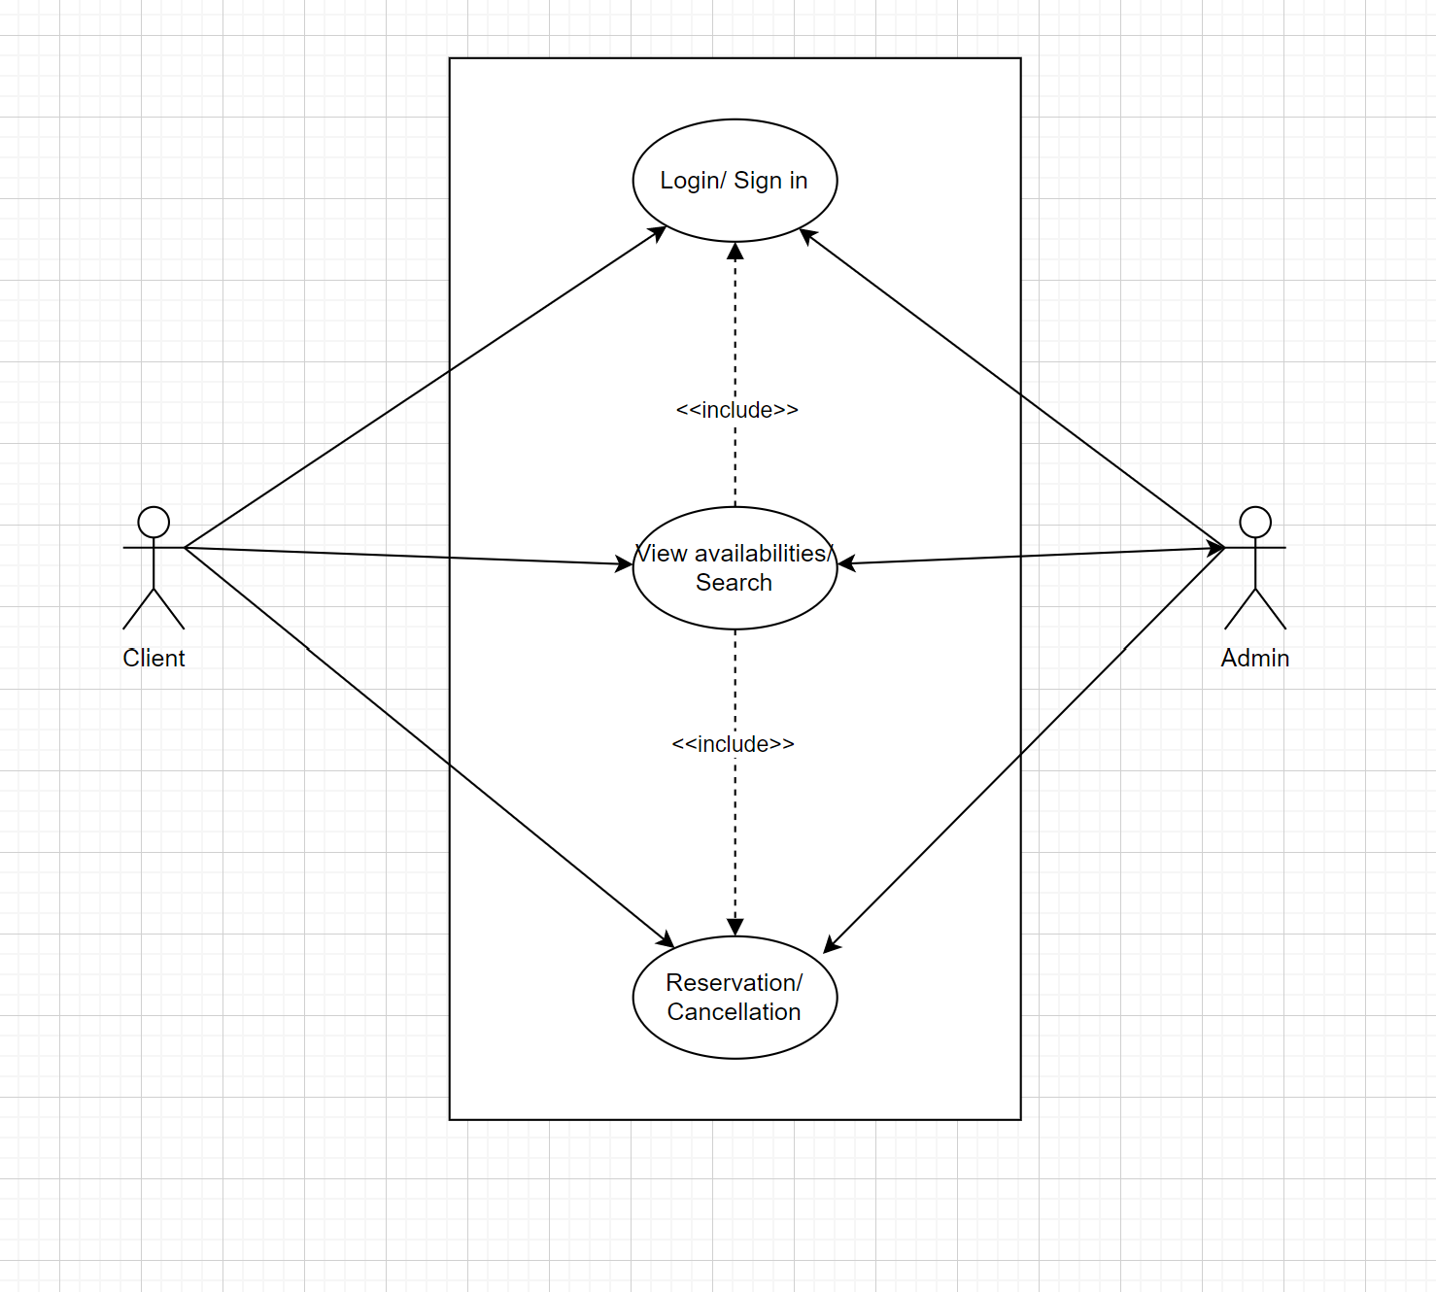

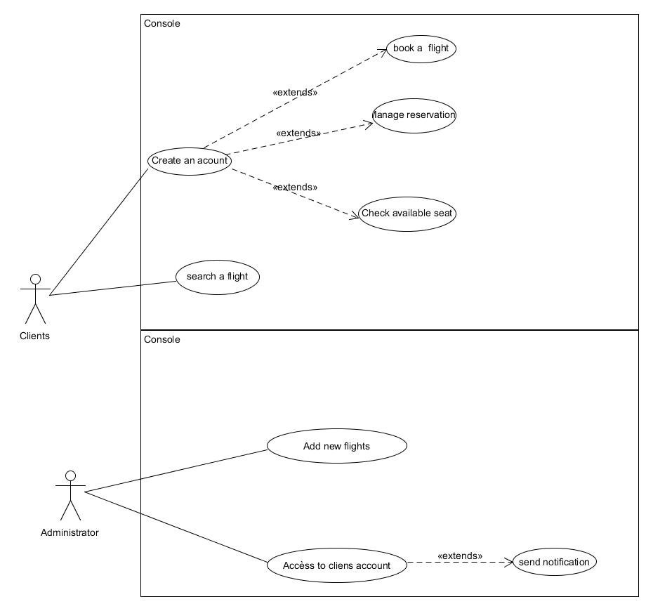

## User Stories

As a client,

I want to search and reserve my ticket, seat number, and pay for it.

So that I can finalize my flight.

As an airline company,

I want to show my available flights, destination, hours, and prices.

So that I can sell my tickets to the clients.

As the service web,

I want to show all the availabilities, reservations in real time,

So that the airline company and the clients can finalize their purchase,

# Design Overview

## System Architecture

dsd

## System Objects

### Class Diagrams

Sdsd

### Class Diagrams Descriptions

sdds

## Constraints and Assumptions

Dsd

## Design Pattern

dsd

# User Interface and Wireframes

## Wireframes

Dsd

## User Interfaces

Dsd

# Database Design

## Entity Relationship Diagram

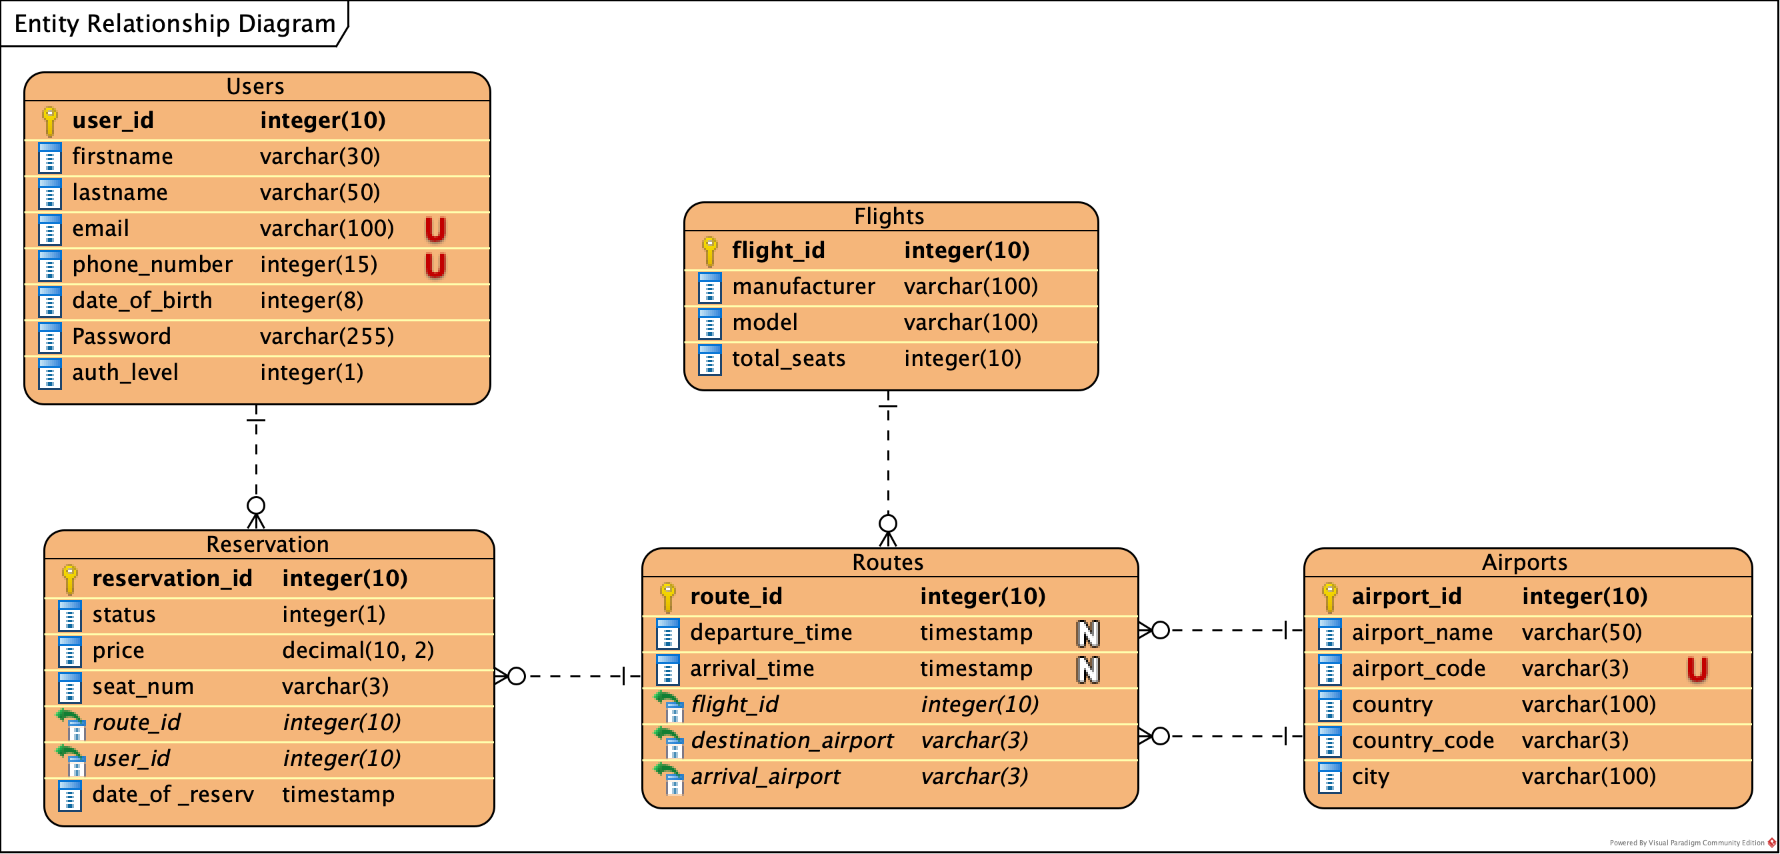

Figure 1 Entity Relationship Diagram

# Dynamic Model

## Flowchart Diagram

Dsd

## Sequence Diagram

dsd

# Non-Functional Requirements

## Performance Requirements

Dsd

## Design Constraints

Dsd

# Testing

## Test Cases

ds